**Assessment 4**

**ITC293-Introduction to Web**

**Name:** Naman Arora

**CSU ID:** 11725847B

**Date of Submission:** 05/05/2024

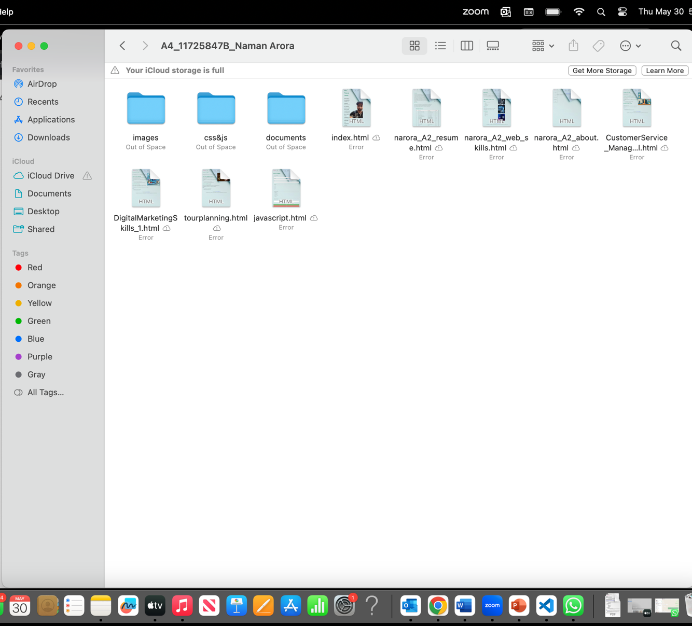

Table of Contents

Introduction: 3

CSS File Plans: 3

Navigation Map/Logical Map: 4

Structure Chart/ Physical Map: 5

Portfolio Storyboard: 6

Page1: 6

Page 2: 7

Page 3: 8

Page 4: 10

Testing: 11

References: 16

# Introduction:

I've created a website for Nova Tech, a company that helps people plan their dream trips around the world. My roll number is 11725847, and when you add up those numbers, you get 8. So, I picked tourism for my imaginary company. The website has seven pages: a home page that welcomes visitors and explains what Nova Tech offers; a resume page that shows the team's skills and experience; an about me page that talks about the company's goals and why it was started; three skill pages focused on tour planning, customer service, and digital marketing that explain how Nova Tech makes travel better; and a web skills page that shows off the technical skills used to build and run the website. There's also a newsletter sign-up form on the site that checks to make sure the first name, last name, and email are entered correctly. This form and other interactive parts of the site are managed with a JavaScript file, while the look and design of the site are made with two external CSS files, making the website easy and pleasant to use. Also using icons, logo’s and images from IMAGEFX, logo.com, Flaticons.com

# CSS File Plans:

## SignUpFormstyles.css:

# The CSS project focuses on styling a web project to ensure consistency and responsiveness across various devices and media. The file structure includes common styles for the body, headers, and navigation; form styles; content wrapper styles; media queries for responsive design; print styles; and footer styles. Common styles set the foundation with font family, margins, padding, line height, color, and background properties. Form styles enhance usability and aesthetics of elements like fieldsets, legends, labels, inputs, and buttons. Content wrapper styles use flexbox layout to maintain consistent section layouts. Media queries adjust layouts for screens smaller than 768px, ensuring a responsive design. Print styles hide unnecessary content and format the remaining content correctly for printing. Footer styles provide a consistent look with background, color, and text alignment. Implementation steps include applying common styles, form styles, content wrapper styles, responsive design adjustments, print styles, and footer styling. Testing involves cross-browser compatibility checks, device responsiveness validation, and print testing. A final review ensures consistency and completeness, with adjustments made as necessary. Documentation of the CSS structure and styles facilitates future maintenance. This structured approach ensures a cohesive and user-friendly design across different platforms.

# Styles.css:

The CSS project involves styling the index page and common elements to create a consistent and responsive design across the web project. The styles encompass general settings for the body, headers, navigation, profile images, text containers, content sections, sidebars, resume sections, tables, and download buttons. The common styles establish the foundation with font family, margins, padding, line height, color, font size, and background properties. The header and navigation styles include padding, background, display, alignment, and hover effects. Profile images and text containers are styled for optimal display, while content containers and sidebars are designed to ensure a cohesive layout. Resume section styles include flexbox layout and specific styling for columns and tables to enhance readability and organization. Media queries ensure responsiveness by adjusting layouts for screens smaller than 768px, transitioning from row to column layout, and adjusting element dimensions and alignments. Print styles hide unnecessary elements and format the remaining content correctly for printing. The footer is styled to match the overall design, providing consistent background, color, and text alignment. Implementation steps include applying common styles, header and navigation styles, profile image and text container styles, content container and sidebar styles, resume section styles, responsive design adjustments, print styles, and footer styling. Testing involves cross-browser compatibility checks, device responsiveness validation, and print testing. A final review ensures consistency and completeness, with adjustments made as necessary. Documentation of the CSS structure and styles facilitates future maintenance. This structured approach ensures a cohesive and user-friendly design across different platforms.

# Navigation Map/Logical Map:

# Structure Chart/ Physical Map:

# Testing:

## Css file testing :

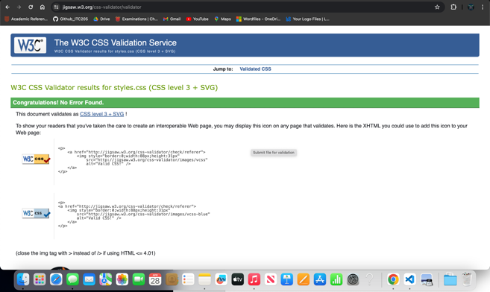 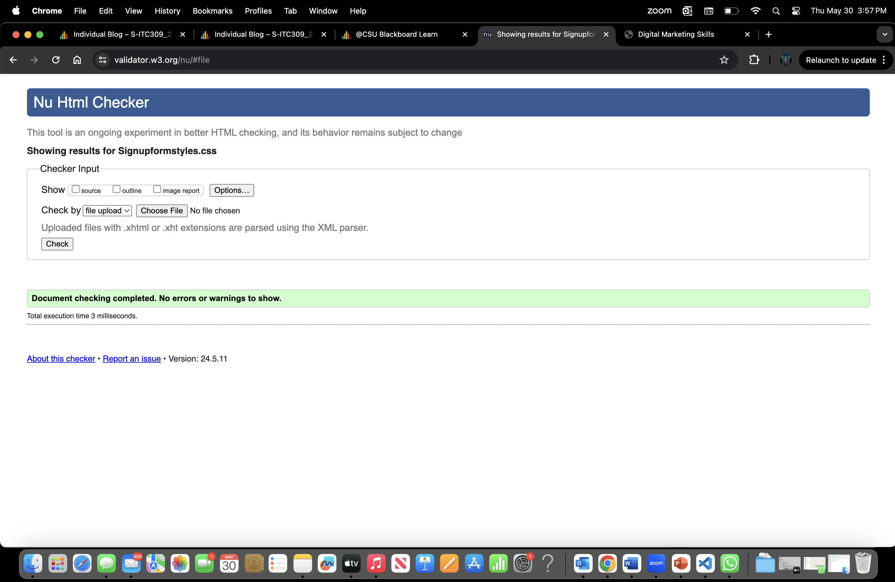

## Testing all the Files with html code:

## Some other tests:

Testing print styles:

As shown in picture the the javascript file is attached properly. And working fine showing popup message:

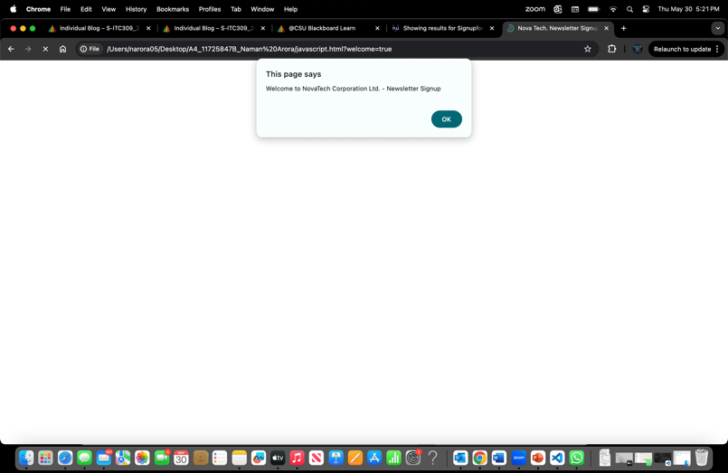

Tried to submit the form without entring the fields it shows error

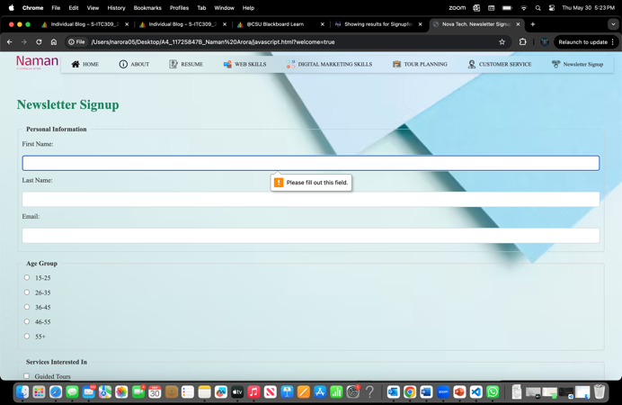

Tried to add more than 60 words in firstname and last name but we cannot add more than 60:

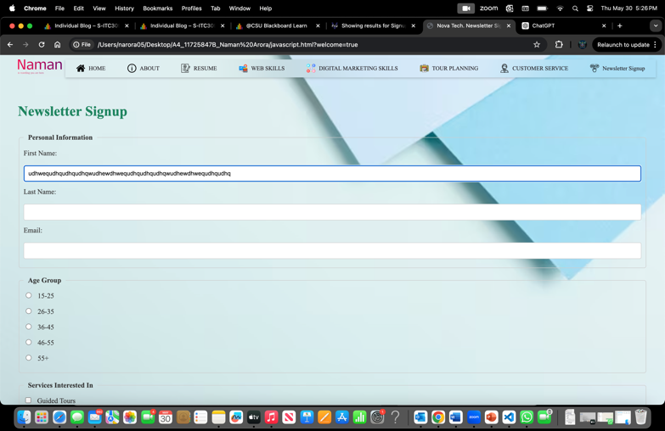

Tried to add Informated email and it shows error please format the email properly.

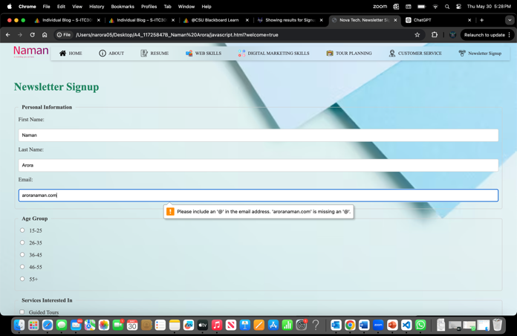

It doesnot allow user to check more than one box in age section:

It allow user to select more than 1 interest in checkbox

The thanku popujp is working properly:

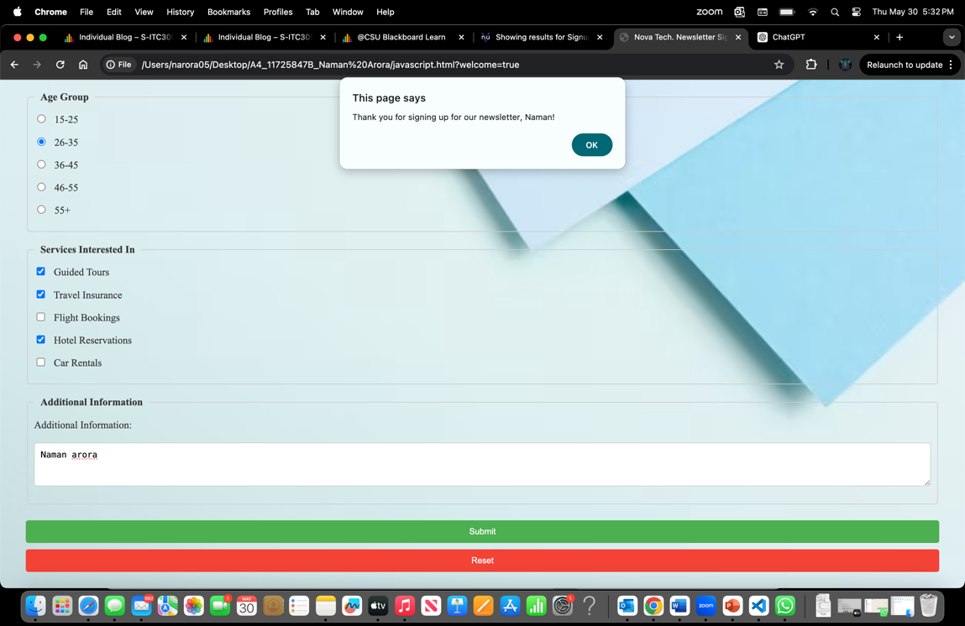

After thanku popup it takes to a new javascript page which notify user that u have signed up for newsletter and also button is giuven to return to home that is index.html:

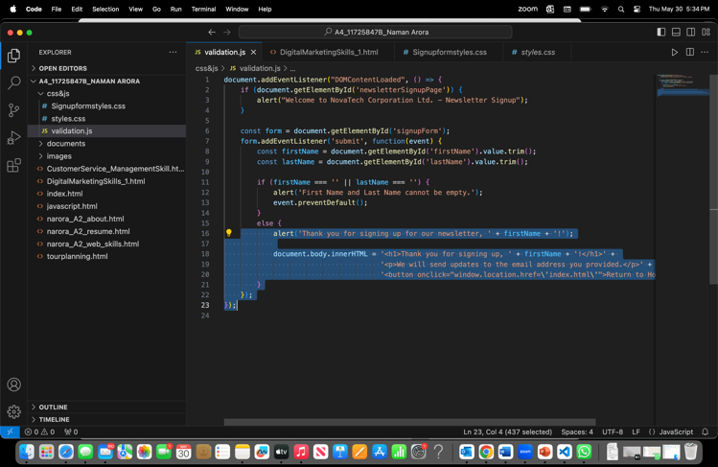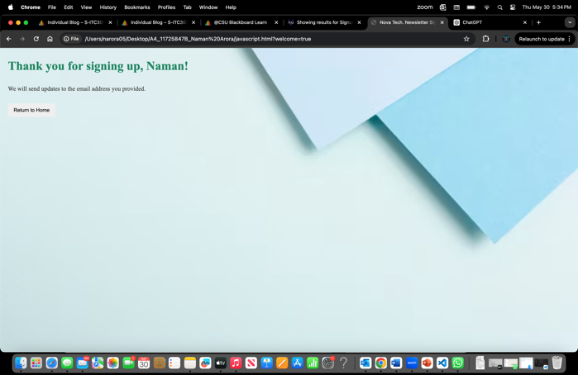

# References:

Flaticon. (n.d.). *Free Icons and Stickers - Millions of images to download*. <https://www.flaticon.com/>

*ImageFX*. (n.d.). <https://aitestkitchen.withgoogle.com/tools/image-fx>

Logo.com. (n.d.). *Welcome*. <https://logo.com/dashboard>